**Tasks**

**Objective Questions :**

**1. What is the total no. of attributes present in the data?**

**Attributes are the columns or features of a dataset that describe its characteristics (e.g., Ticket ID, Issue Type, Agent Name).**

**The dataset consists of two sheets:**

* **Tickets sheet: 10 attributes**
* **IT Agents sheet: 6 attributes**

**Total attributes = 16**

**Formula used: =COUNTA(A1:J1)**

**2. Which columns have inconsistent or missing values, and what is the count of such values?**

**Missing values are empty cells in the dataset, while inconsistent values are entries that do not follow the expected format or range.**

* **Missing Values:  
    
   Checked using =ISBLANK() across all columns. No blank cells were found.  
  Result: 0 missing values.**

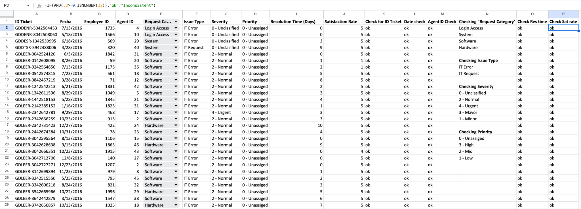

* **Inconsistent Values:  
    
   Different validation rules and formulas were applied for each column:**
  + **Ticket ID: =IF(AND(LEN(A2)<>17,LEFT(A2,7)<>"-"),"Inconsistent","OK")**
  + **Date: =IF(ISDATE(B2),"OK","Inconsistent")**
  + **Agent ID: =IF(AND(D2>=1,D2<=50),"OK","Inconsistent")**
  + **Request Category, Issue Type, Severity, Priority: Checked with Data Validation and =UNIQUE() to flag invalid entries.**
  + **Resolution Time: =IF(AND(I2>=0,ISNUMBER(I2)),"OK","Inconsistent")**
  + **Satisfaction Rating: =IF(AND(J2>=0,ISNUMBER(J2)),"OK","Inconsistent")**
* **Spell Check:**

**Using the Find and Replace feature, spelling errors like “Mayor”, “Unassiged” and “Unclasified” were replaced by their correct spellings.**

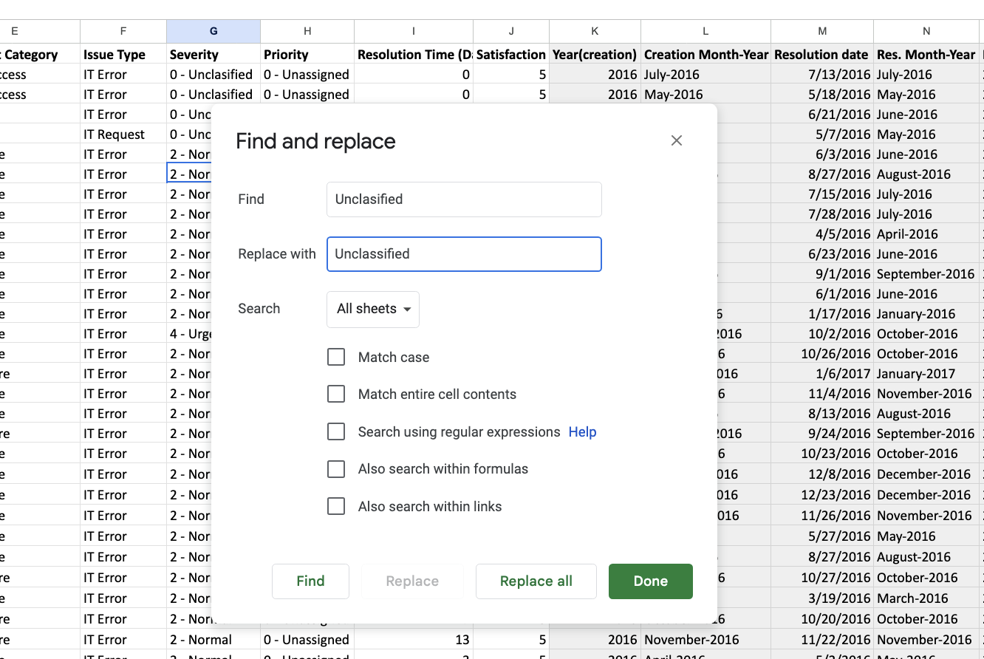

**Final Observation:**

**The dataset has 0 missing values and 0 inconsistent values.**

**The spelling errors were corrected using Find and Replace feature across all sheets.**

**3. What is the average daily ticket volume over time?**

**Answer:**

**The daily ticket volume represents the number of tickets received each day.**

* **A Pivot Table was created with Date in rows and Count of Ticket IDs in values to calculate daily ticket counts.**

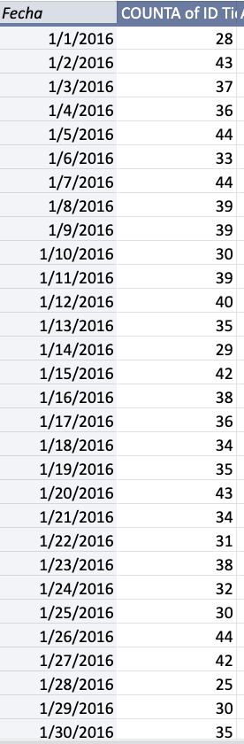

* **Applying the formula:**

**=Average() on the column of daily ticket volume**

**Answer= 53.365**

**4. What is the distribution of ticket categories (e.g., Login Access, System, Software)?**

* **Ticket categories represent the type of issue reported in the system.**
* **A Pivot Table was created with Request Category in rows and Count of Ticket IDs in values.**

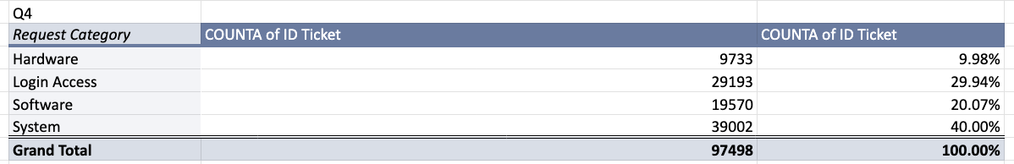

* **System tickets form the largest share (40%).**
* **Login Access is second largest (~30%) → frequent recurring issue.**
* **Software requests are moderate (20%).**
* **Hardware has the lowest share (~10%).**
* **Together, System + Login Access = ~70% of total workload → priority focus areas.**

**5. How many tickets has each agent handled?**

* **Pivot table created to get the no. of tickets handled by each agent**

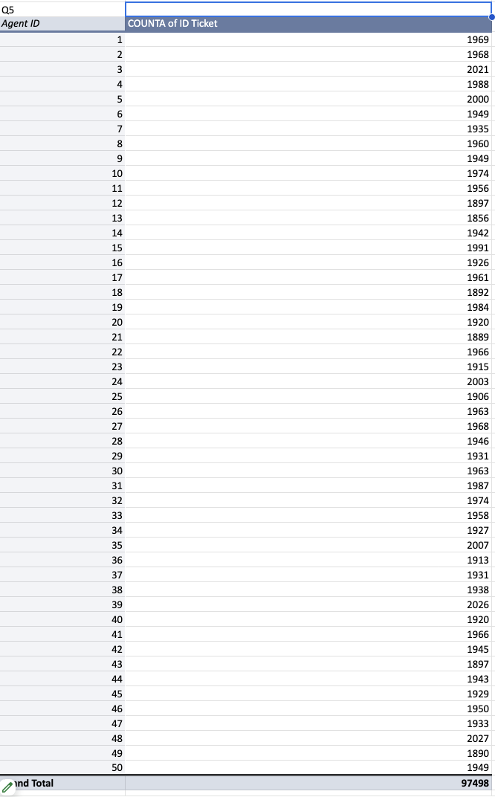

**6. How can you extract the domain from the email addresses in the IT Agents sheet?**

**Formula used : =RIGHT(C2,len(C2)- FIND("@",C2))**

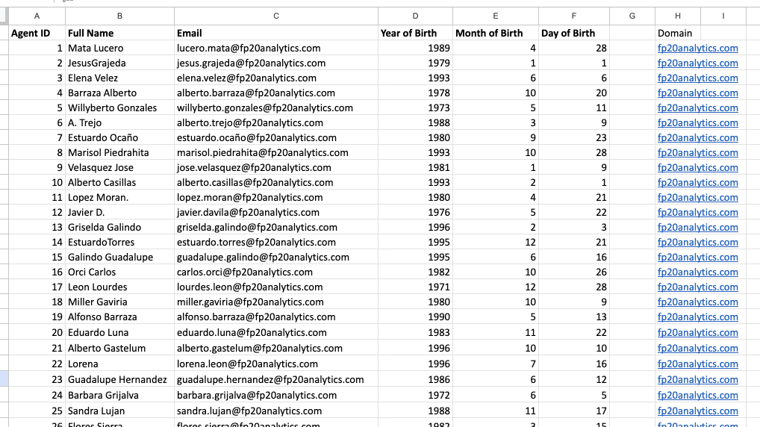

**BUT, if we want Domain without extension, we used :**

**Formula: =MID(C2, FIND("@",C2)+1, FIND(".",C2,FIND("@",C2)) - FIND("@",C2) - 1)**

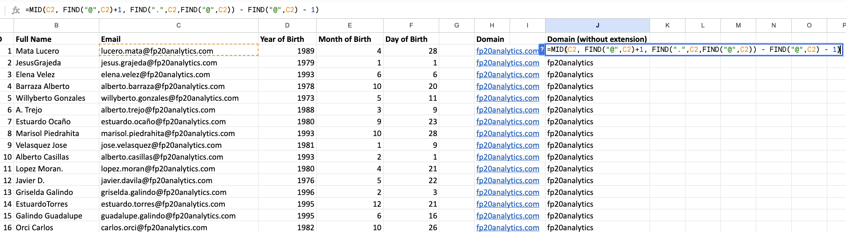

**7. How can you find the full name of an agent given their Agent ID?**

**This can be done using Xlookup.**

**Formula used :**

**=XLOOKUP(K29,'IT Agents'!$A$2:$A$51,'IT Agents'!$B$2:$B$51)**

**8. What is the count of each issue type (e.g., IT Error, IT Request)?**

* **We have created a pivot table to get this data**

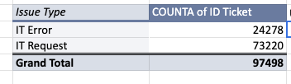

**9. What is the daily average resolution time for tickets?**

**Answer:**

**We take the average of the column named “Resolution Time(Days)”**

**Formula used : =AVERAGE(Tickets!$I$2:$I$97499)**

**Avg= 4.553 days**

**10. How has the volume of tickets changed over time?**

* **Created a Pivot Table with ‘CountA of ID Ticket ‘ in Values, and Year-Quarter in Rows. Also a Chart for visualisation**

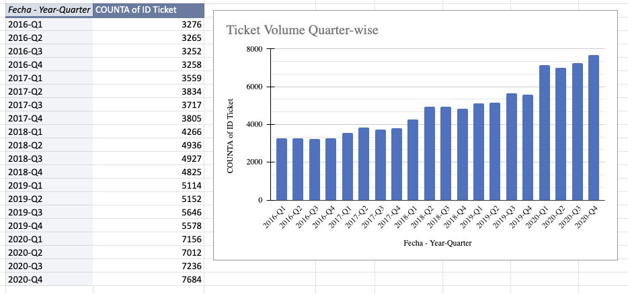

**11. What is the average age of the IT agents?**

**Answer:**

**In the IT Agents worksheet, the Date, Month, Year of birth of each agent was provided. To calculate their ages:**

1. **The current date was considered as *31st January 2021*.**
2. **Full DOB was formed from the year, month, and day using the =DATE(year,month,date) function.**

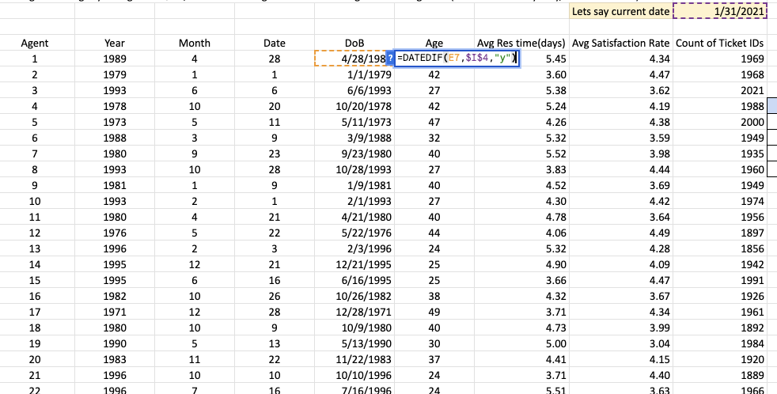

1. **The age of each agent was calculated using the =DATEDIF() function.**

**Average was calculated using =AVERAGE() formula which came out to be -> 35.36**

**12. Is there a correlation between the severity of issues and the resolution time?**

**Answer:**

**Severity refers to the criticality of a ticket (Unclassified, Minor, Normal, Major, Urgent), while Resolution Time is the number of days taken to resolve it. To analyze correlation:**

* **A Pivot Table was created with Severity in rows and Average of Resolution Time in values.**

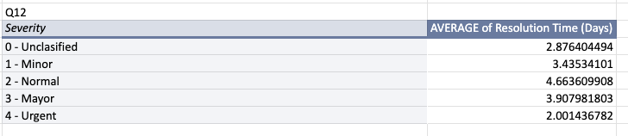

**Observation:**

* **Normal issues take the longest time to resolve (4.66 days).**
* **Urgent issues are resolved the fastest (2.0 days), reflecting prioritization.**
* **Minor and Major issues fall in between.**

**Conclusion: There is a clear correlation — higher urgency generally leads to faster resolution, while normal/non-urgent issues tend to take longer.**

**13. How many categorical columns are there in the data? [Search about categorical and continuous data, and try to answer this question]**

**Answer:**

* **Categorical data represents qualitative, fixed categories (e.g., names, labels, groups).**
* **Continuous data is numeric and measurable (e.g., resolution time, satisfaction rate).**

**Categorical Columns Identified:**

* **In Tickets Sheet (7):**
  1. **ID Ticket**
  2. **Employee ID**
  3. **Agent ID**
  4. **Request Category**
  5. **Issue Type**
  6. **Severity**
  7. **Priority**
* **In IT Agents Sheet (3):**
  1. **Agent ID (repeat)**
  2. **Full Name**
  3. **Email**

**Total Categorical Columns = 10**

**Subjective Questions**

1. **If there is an investment, should it be used to hire more IT agents, improve training programs, or upgrade ticket management software?**

**Approach & Observations**

* **To make an investment related decision, we first need to analyse the performance of the team over the years. We’ll scrutinize time periods where significant increase in team performance was observed. This can help us towards better decision making.**
* **A quarterly pivot analysis (2016–2020) with Avg resolution time, Avg satisfaction rate, and ticket volume shows that ticket count has steadily increased, especially between 2019–2020, while average resolution time and satisfaction rate have remained fairly stable.**

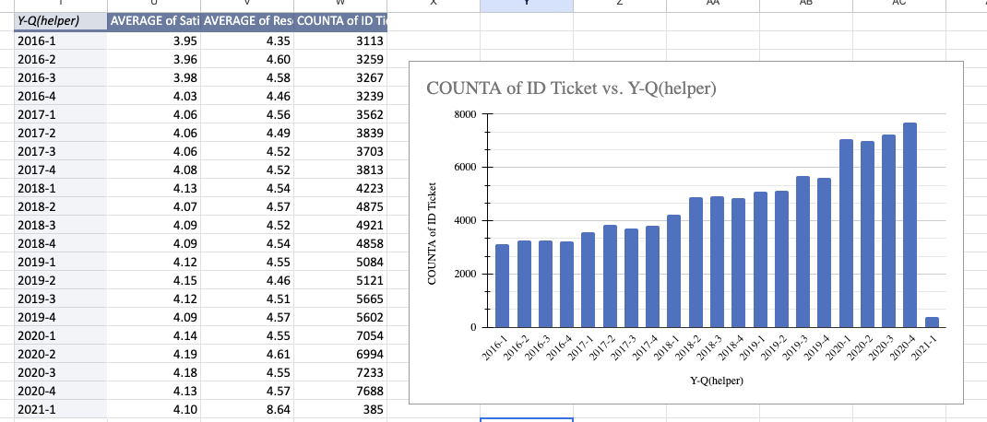

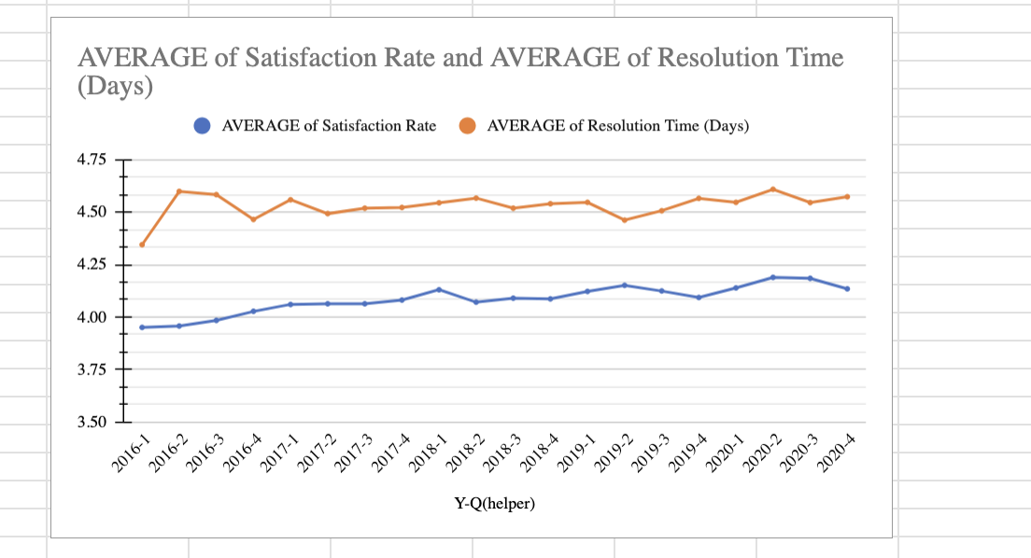

* **An efficiency score was created:  
    
  Efficiency Score = (Avg Satisfaction Rate/Avg Resolution Time) * Ticket Volume**

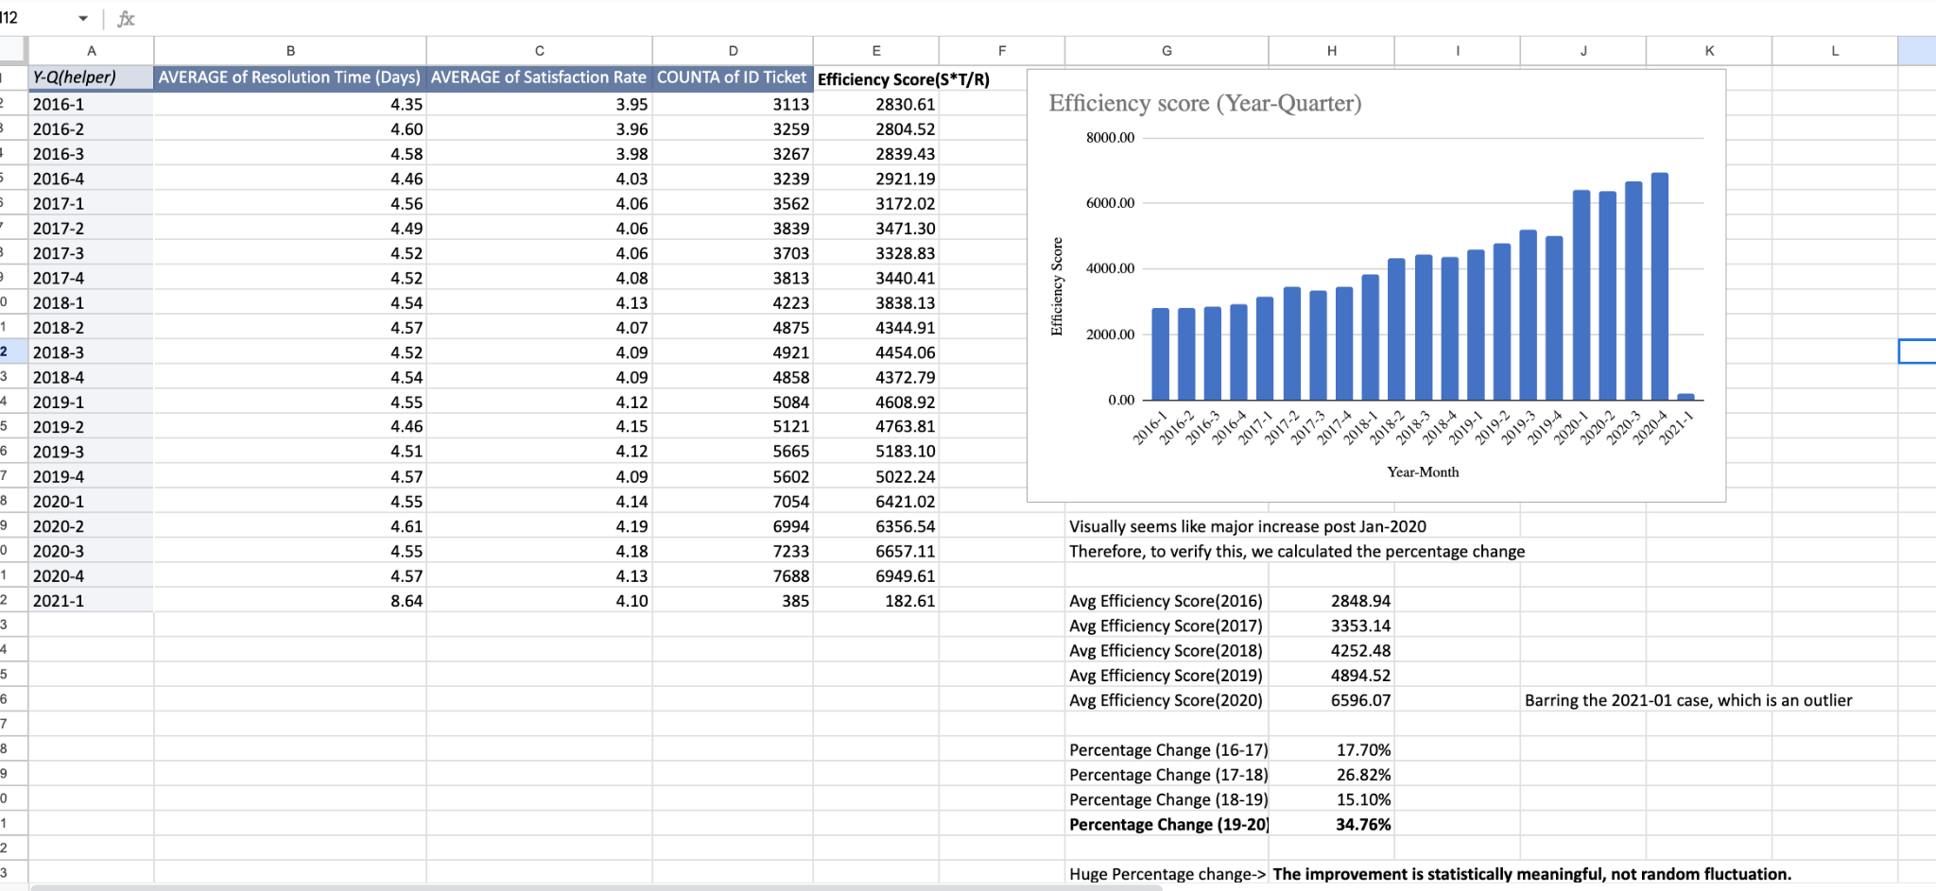

* **This score increased by ~34% between 2019 and 2020. So lets narrow down on this time period to analyse what led to this significant increase in performance.**
* **The improvement is almost entirely due to the sharp rise in ticket volume (~34.9%), while resolution time actually increased slightly (+1.07%) and satisfaction improved only marginally (+0.97%).**

**This means efficiency gains came from higher ticket volume resolved, not from faster resolution or much higher customer satisfaction.**

* **A deeper check of tickets per agent, in the same time period, shows that ticket per agent increased by ~34.9 %. This tells us that increase in tickets resolved was because each agent handled more tickets (and therefore Not because of increased headcount)**

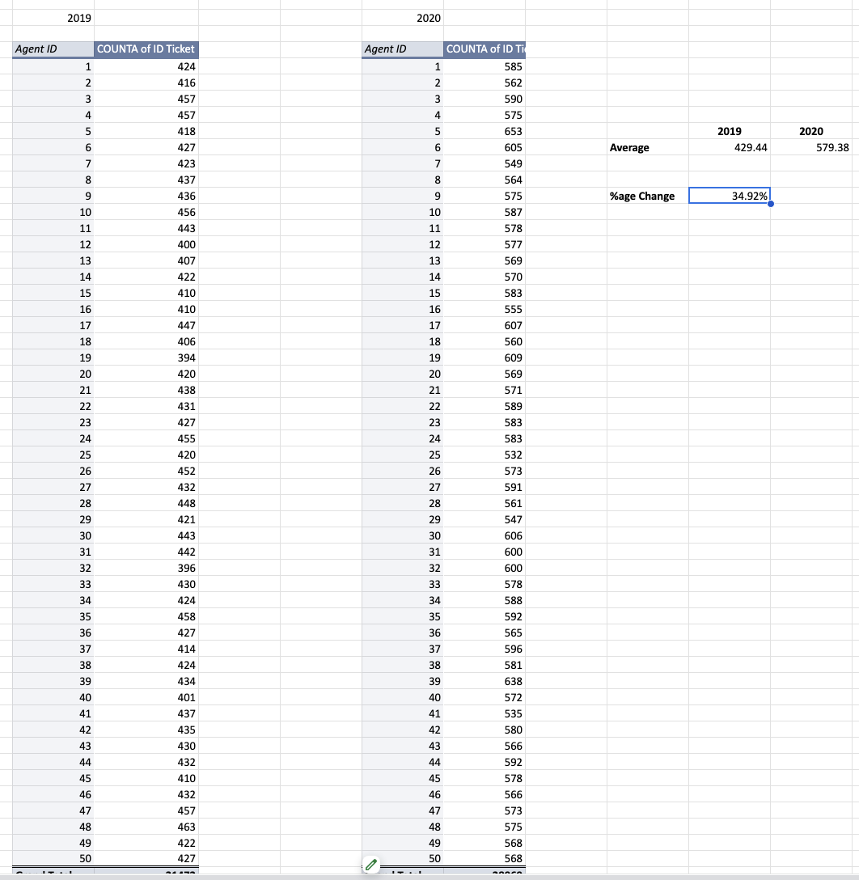

**Insights:**

* **The growth in tickets handled per agent suggests that upskilling/training programs were applied, enabling agents to manage higher workloads without a major drop in satisfaction.**
* **Since the Avg Resolution Time increased, instead of decreasing, it suggests that no major software upgrade was made during that time.**
* **And we can surely say that Training/Upskilling drove the increased ticket volume and therefore the higher efficiency score.**
* **Thus, we can observe that upskilling/training the current team of agents can boost team performance significantly(~34%) without affecting customer satisfaction. This clearly indicates how impactful it is to invest in training**
* **Correlation analysis between metrics (resolution vs satisfaction, tickets vs satisfaction, etc.) showed only weak-to-moderate relationships, confirming that correlation is not a strong driver of this decision.**
* **Now to confirm our inclination towards investing in Training, a granular agent-level decision matrix (using resolution time, satisfaction, and ticket load) was created to substantiate the decision.**
* **It primarily focused on the worse performing agents ,using Quartiles (Using percentile thresholds, resolution time above the 75th percentile was considered *High*, while satisfaction rate below the 25th percentile was considered *Low,* Tickets per agent below 25 percentile was considered Low).**
* **It also pointed to Training as the most frequently recommended and relevant action across the team.**

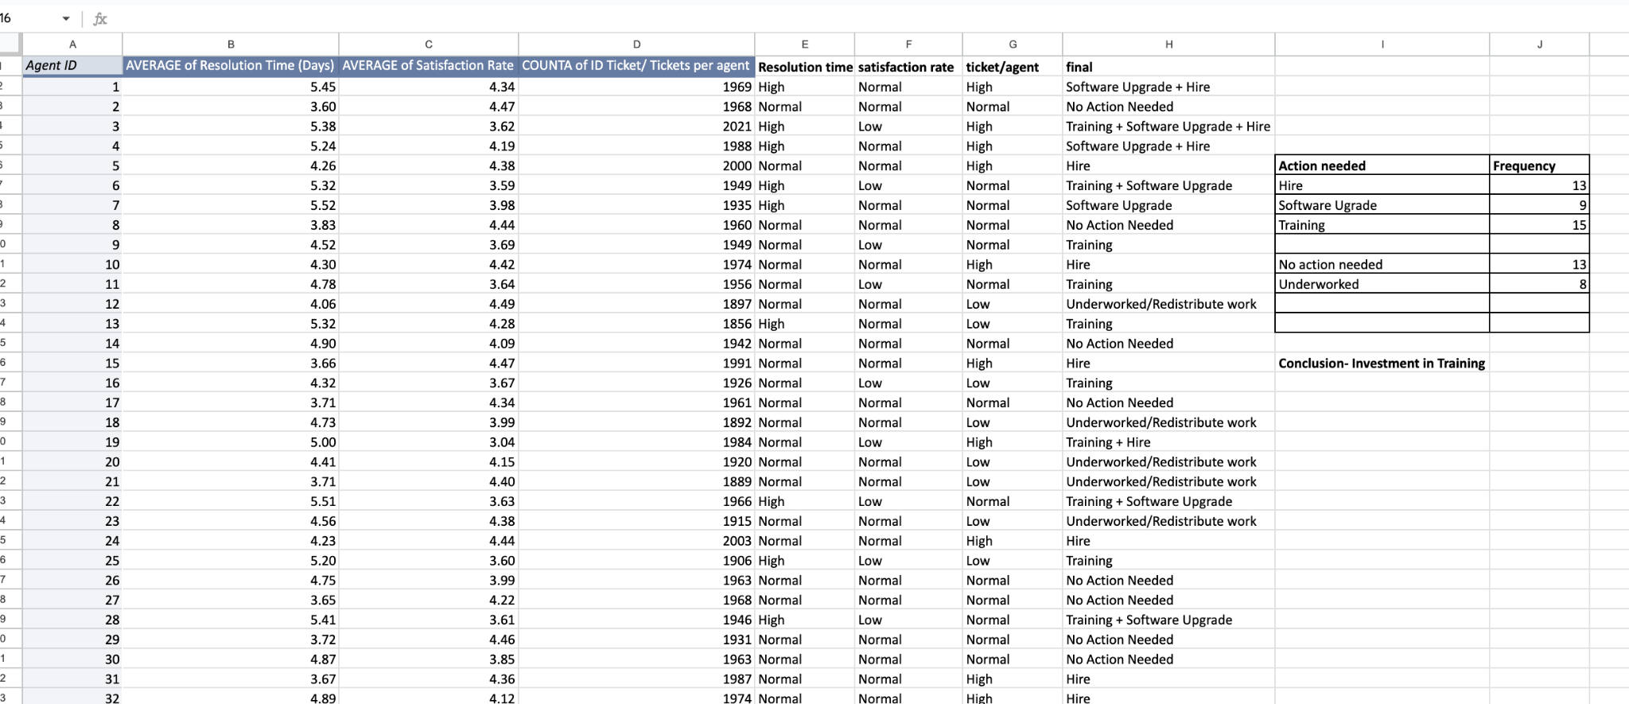

**Recommendation:**

* **Investment should be directed primarily towards Training Programs, since both macro-trend efficiency analysis and micro-level agent diagnostics confirm that skill improvement drives better handling of rising ticket volumes.**
* **Software Upgrades can be considered as a secondary measure for long-term scalability, but current evidence shows that training yields more immediate benefits.**
* **Hiring more agents should not be prioritized at this stage, as tickets per agent increased significantly without additional staff, proving that efficiency gains are possible through capability building rather than headcount expansion.**

**2. Which agents need additional training based on their performance metrics?**

**Observation:**

* **A pivot table of agent-wise averages was created with resolution time, satisfaction rate, and tickets per agent.**
* **Using percentile thresholds, resolution time above the 75th percentile was considered *High*, while satisfaction rate below the 25th percentile was considered *Low*.**
* **Based on this classification, several agents consistently showed both high resolution times and low satisfaction ratings. These agents fall behind the team average in terms of efficiency.**

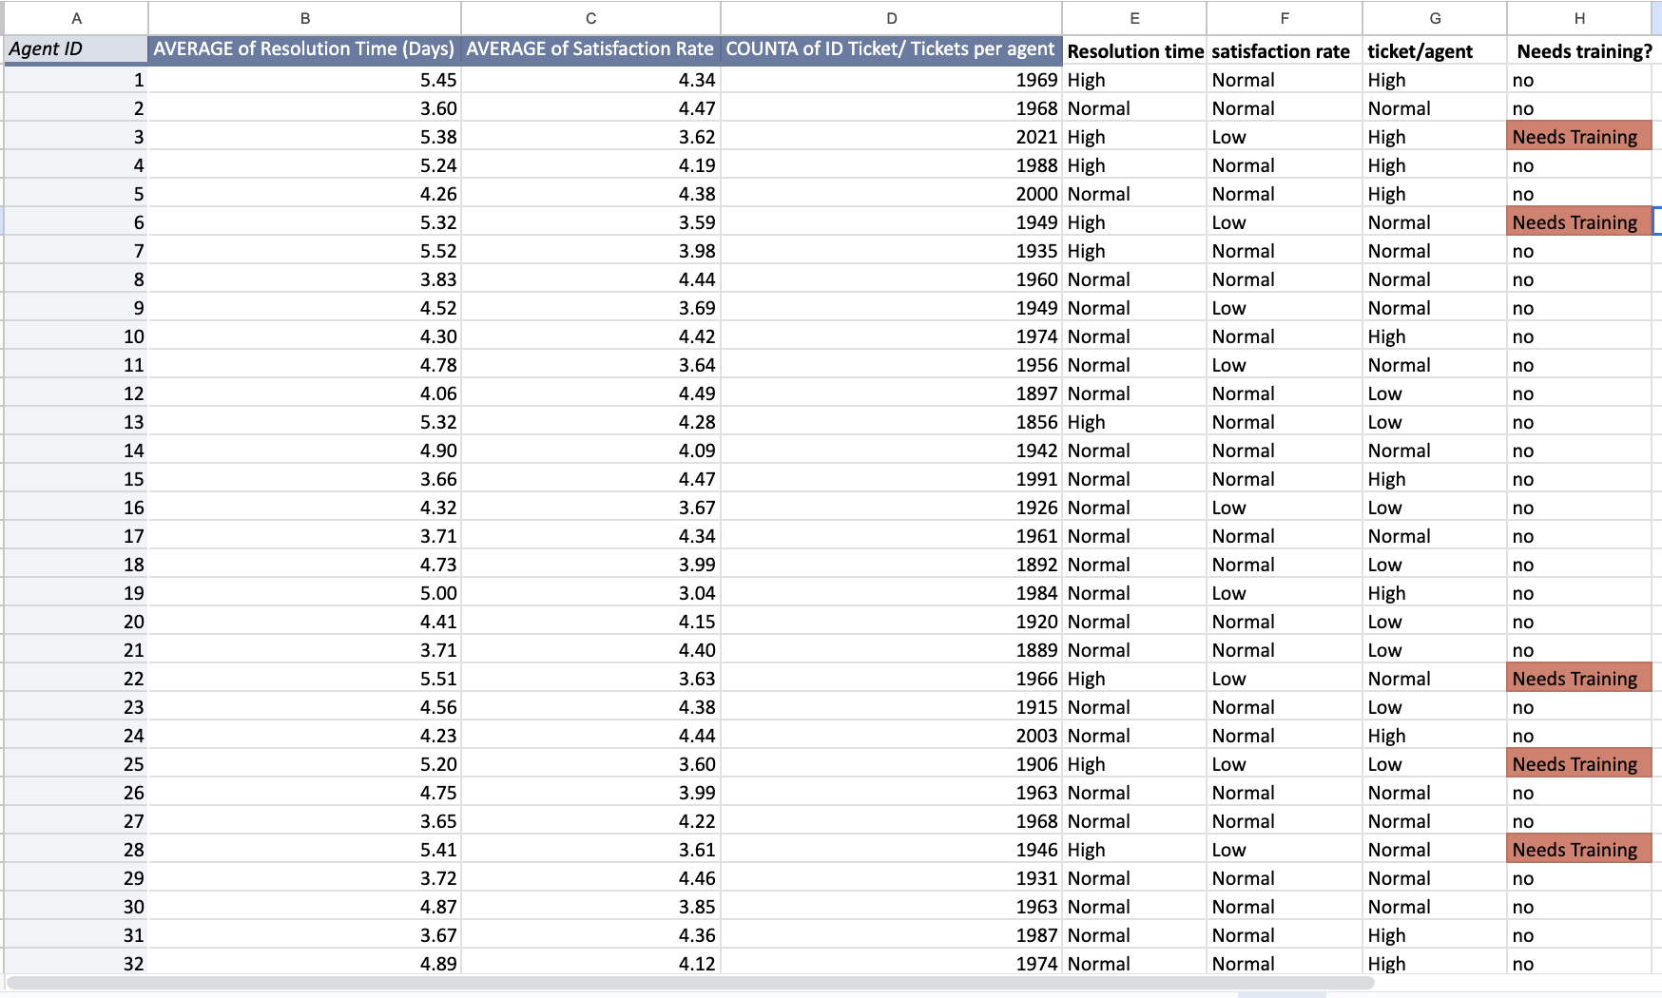

**Insight:**

* **Agents 3, 6, 22, 25, 28 showed a combination of higher-than-normal resolution times and below-average satisfaction scores, suggesting clear performance gaps.**
* **These agents struggle both with speed (time to resolve tickets) and quality of service (satisfaction score).**
* **The problem does not appear to be ticket overload alone, because not all high-ticket agents fall into this category. Instead, it suggests skill or process gaps.**
* **If not addressed, these underperforming agents may pull down the overall service quality and efficiency of the IT support team.**

**Recommendation:**

* **Prioritize targeted training programs for the identified agents to improve both speed and customer handling quality.**
* **Training should focus on:  
  a) Technical efficiency (to reduce resolution time).  
  b) Soft skills and customer interaction (to improve satisfaction).**
* **Performance of these agents should be re-evaluated after training via KPIs (resolution time trend, satisfaction ratings).**
* **Agents performing at average or above-average levels should not be included in broad training — instead, focus resources on the specific underperforming group (through percentile method) for maximum impact.**

**3. Do certain categories of requests have longer resolution times?**

**Observation:**

**From the category summary pivot:**

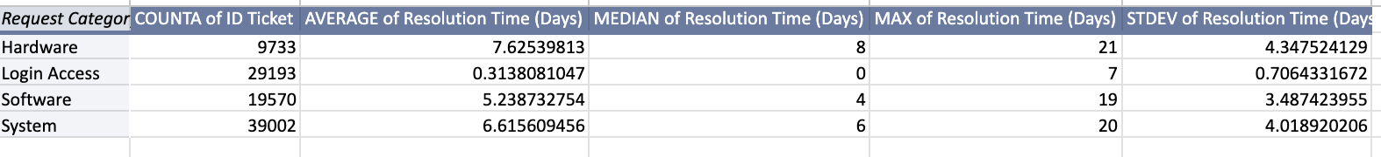

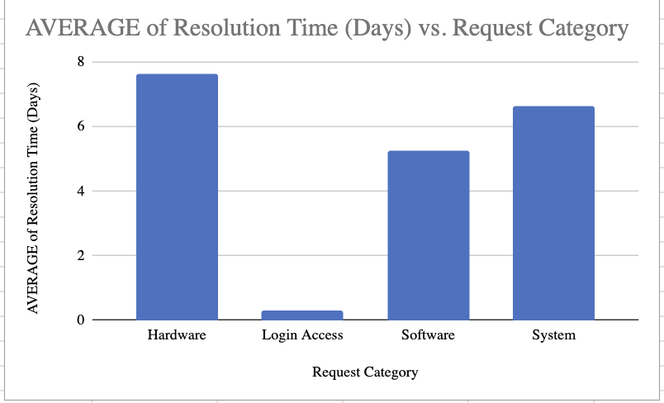

* + **Hardware requests have the highest average resolution time (7.62 days) and wide variability (SD = 4.35), with some cases taking up to 21 days.**
  + **System requests also take long (6.61 days avg, max 20).**
  + **Software requests average at 5.23 days, moderately high but less variable.**
  + **Login Access requests are resolved extremely quickly (0.31 days on average) and consistently (very low SD).**
* **From the resolution-day distribution pivot:**
  + **The majority of Login Access tickets are resolved within 0–2 days, showing efficiency and standardized processes.**

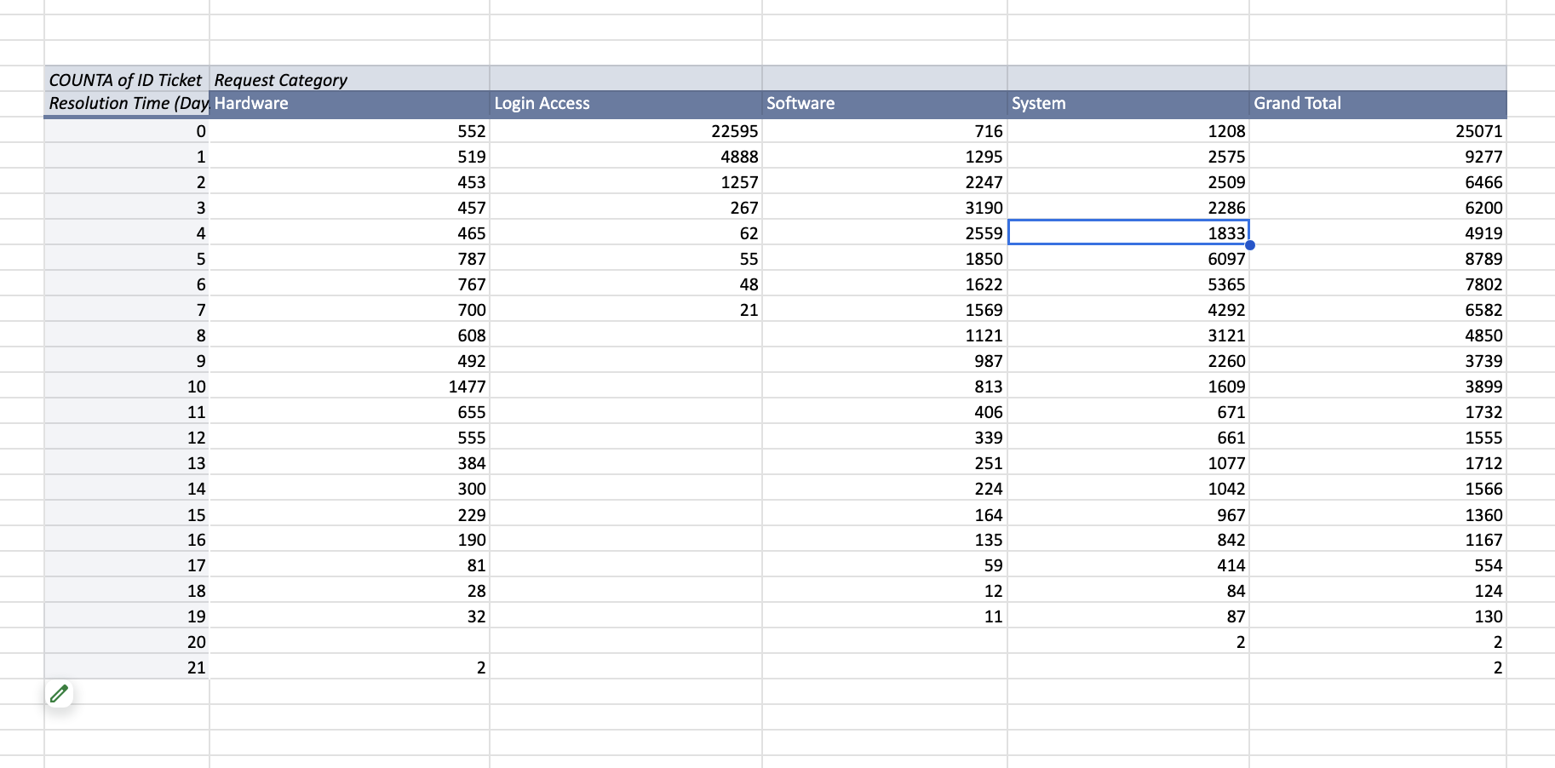

* + **Hardware, Software, and System tickets spread across 0–15+ days, with a significant number stretching beyond 7 days, confirming their slower and less predictable nature.**
  + **Hardware and System requests show a heavy tail (long delays)**

**Insight:**

* **Login Access issues are fast-tracked, maybe because of automated or standard workflows (e.g., password reset, access provisioning).**
* **Hardware and System requests take the longest due to dependencies (physical repairs, infrastructure checks, vendor coordination), leading to delays and inconsistency.**
* **Software requests are less severe but still require multiple days, possibly linked to troubleshooting complexity.**
* **The distribution highlights a clear pattern of backlog in Hardware and System tickets, whereas Login Access is almost always solved within a day.**

**Recommendation:**

* **Hardware/System Requests : Focus investment on streamlining processes and if possible, try adding automation to some parts. If possible, create a specialized fast-response team.**
* **Software: Provide additional technical training to reduce average handling time.**
* **Login Access requests : Good performing, so maintain automation and standardized workflows; explore applying similar automation to parts of the Hardware/Software pipeline.**
* **Regularly monitor the tickets that are taking more time.**

**4. How effective are the current software tools in managing IT tickets?**

**Observation:**

**T*he dataset does not provide any explicit information on the timing of new tool implementation. Therefore, we cannot directly compare “before vs after” periods. Instead, we examined performance trends around the most recent years (2019–2020) to infer effectiveness.***

**Since the question focuses on the *current software tools*, the analysis primarily considered the most recent full year (2020), with 2019 included as a baseline for comparison. A pivot was created, with major focus on these two years, tracking average resolution time, average satisfaction rate, and ticket count.**

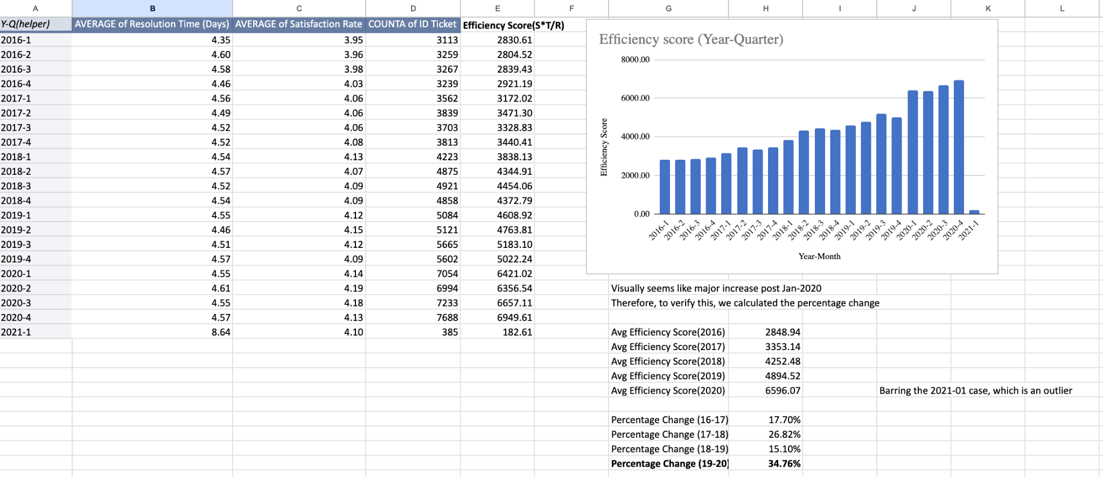

**An Efficiency Score was calculated as:**

**Efficiency Score = (Avg Satisfaction Rate/Avg resolution Time)* Tickets**

* **The score rose sharply by ~34.7% between 2019 and 2020, suggesting improved output at first glance.**
* **But detailed review shows:**
  + **Average Resolution Time increased slightly (+1.07%), which is counter to what we’d expect if better tools were helping.**
  + **Its evident by this graph, that Avg. Resolution Time has been more or less similar (in fact an increase by 1.07%)**

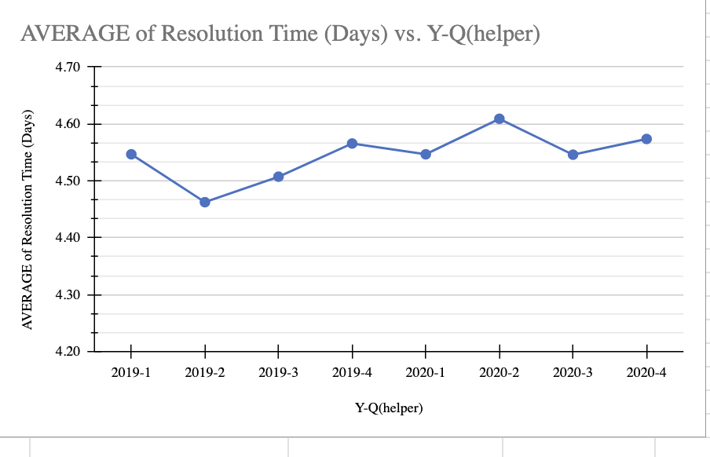

* + **Average Satisfaction Rate improved only marginally (~0.97%).**
  + **Ticket Volume per agent rose ~34.9%, which almost entirely explains the efficiency gain.**
  + **We can clearly see that Improvement in efficiency score is due to agents handling more tickets, not due to faster resolution or significantly higher customer satisfaction.**

**Additional check: Severity–Priority alignment**

**To further test effectiveness, we compared whether higher severity tickets are consistently assigned higher priorities.**

### **What we’re expecting (ideal alignment):**

* **Urgent & Major severity tickets should mostly map to High priority.**
* **Minor severity tickets should map more to Low priority.**
* **Normal severity will usually be spread, but a large share under Mid priority is reasonable.**
* **Very few severe tickets should be left Unassigned — if they are, it shows poor system effectiveness.**

**A Pivot Table was created to check the alignment**

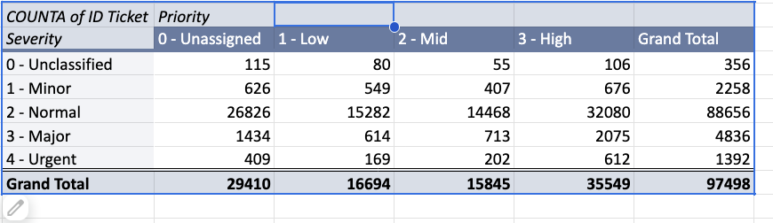

* **Urgent severity (1,392 tickets):**
  + **612 marked High priority → Good**
  + **But 409 are Unassigned and 371 combined in Low/Mid → Misaligned.**
  + **This means ~56% are not properly flagged high priority.**
* **Major severity (4,836 tickets):**
  + **Only 2,075 (43%) flagged High priority**
  + **A significant chunk (1,434 unassigned, 614 low) → shows weak mapping.**
* **But since the question asks about the current state of software, so we narrow our focus to 2019-2020**

**For analysing the Current software in terms of alignment, we compared the 2 years, 2019 and 2020 by applying filters on the pivot:**

**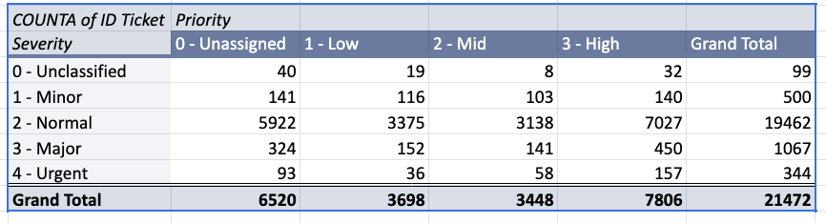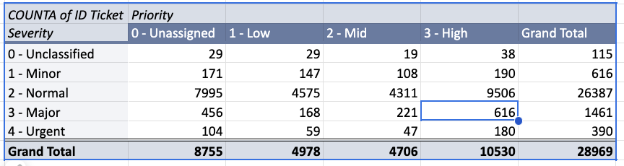  
( 2019 and 2020 respectively)**

**2019 (first table):**

* **Urgent tickets (344 total): Only 157 (45%) were High priority. The rest are scattered in Unassigned/Low/Mid.**
* **Major tickets (1,067 total): Just 42% (450 tickets) in High priority, and 30% left Unassigned.**
* **Normal tickets (19,462 total): Most split across all levels, but a very large block (30%) is still High.**
* **Minor tickets: ~28% assigned to High, which is *not* ideal.**

**2020 (second table):**

* **Urgent tickets (390 total): 46% (180 tickets) are High priority → slightly better than 2019 but still weak.**
* **Major tickets (1,461 total): Only 42% High, while ~31% Unassigned. No improvement from 2019.**
* **Normal tickets: High share grew even more (36% at High), which suggests over-prioritization.**
* **Minor tickets: Still 30% High priority → misaligned.**

**The analysis revealed major gaps:**

* **Even in the most recent year (2020), the alignment between severity and priority remains weak. Urgent and Major issues — which should consistently be mapped to High priority — are not reliably prioritized. At the same time, Minor issues are disproportionately marked as High priority.**
* **This misalignment indicates that the current software tools are not enforcing prioritization logic effectively.**
* **Therefore, while the software handles volumes, it cannot be considered effective in aligning ticket severity with priority, which is a key function of IT ticket management.**

**Insight:**

* **The improvement in efficiency is due to agents handling more tickets, not due to faster resolution or significantly higher customer satisfaction.**
* **This suggests the current software tools are stable enough to support increased workloads but not actively driving efficiency gains, instead counter-intuitively, there’s an increase in Avg. resolution time**
* **Severity–priority misalignment shows that the current tools are not ensuring proper escalation of critical issues, while normal/minor issues consume high-priority slots.**
* **This suggests the current software tools are stable enough to sustain workloads but fail at optimizing prioritization and efficiency.**

**Recommendation:**

* **The current software cannot be considered highly effective in improving IT ticket management. While it sustains higher ticket loads, it does not reduce resolution time, improve satisfaction, or ensure correct severity-priority alignment.**
* **Any future tool implementation must focus on automating and primarily on enforcing severity-priority mapping so that Urgent/Major issues always receive High priority and Normal/Minor tickets are not over-prioritized.**
* **Even the slight increase (1.07%) in resolution time is a red flag — better software should reduce this metric.**
* **Any future tool implementation should be paired with clear before–after performance tracking to measure its impact more transparently.**

**5. How has the performance of the IT support team changed over time (e.g., monthly or quarterly)?**

**Observation:**

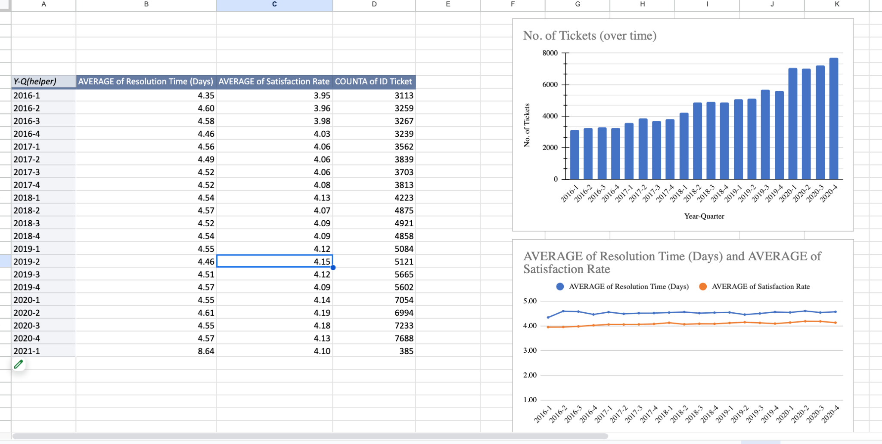

* **Overall Performance (Fig. 1): Quarterly ticket volume rises steadily through 2016–2020, with a clear jump in 2019–2020. Despite this growth, Average Resolution Time stays broadly flat in a narrow band (≈4.5–4.6 days), and Average Satisfaction Rate trends slightly upward (low 4s).**
* **We have already seen the overall efficiency scores earlier.** 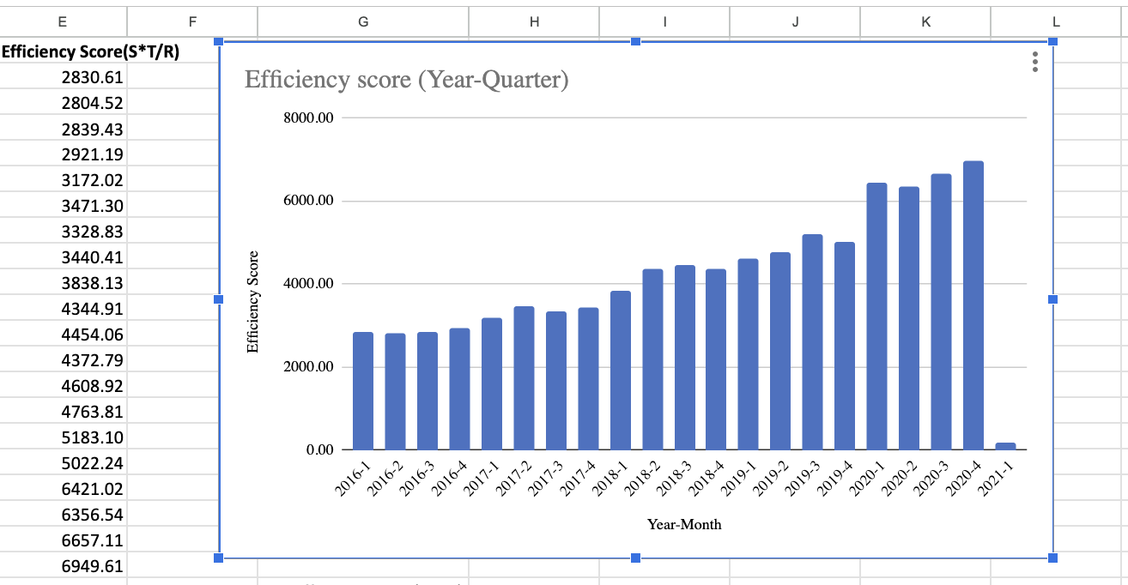

**To gain deeper insights, filters were applied:**

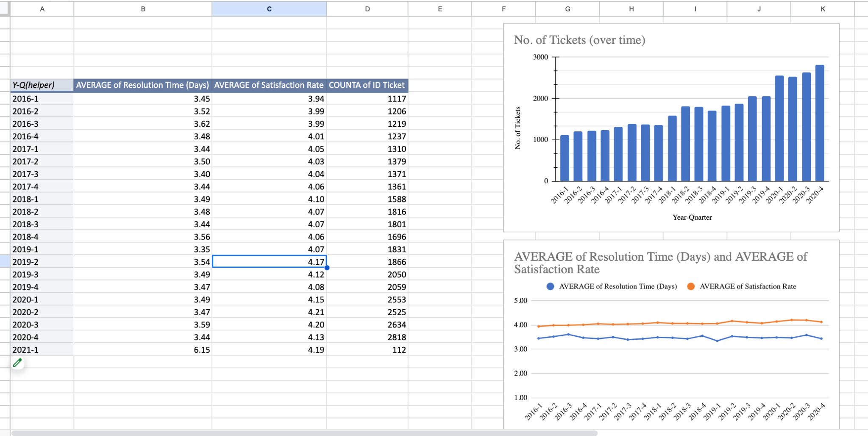

* **High Priority only (Fig. 2): Ticket counts are lower than overall but grow over time. Resolution time is lower than the overall average (≈3.4–3.6 days) and relatively stable; satisfaction remains around the low 4s with mild fluctuations.**

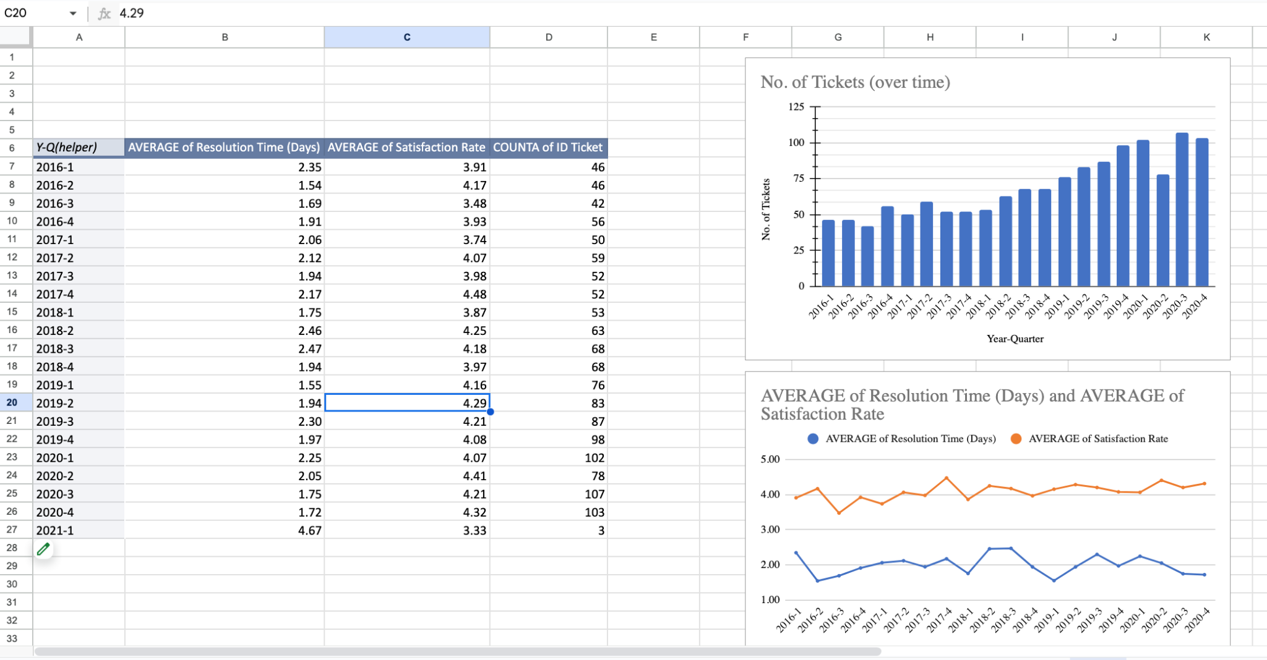

* **Urgent severity only (Fig. 3): Ticket counts are very small (dozens per quarter) but increase over time. Resolution time is shortest (≈1.7–2.5 days) as expected for Urgent severity, yet most volatile quarter-to-quarter; satisfaction hovers around ~4 and swings more than in the other views.**

**Insight:**

* **The team has scaled well: more tickets handled without a deterioration in overall resolution time and with slightly improving satisfaction.**
* **Under pressure:**
  + **High priority work is managed with faster-than-overall times and stable satisfaction—process discipline looks decent here.**
  + **Urgent cases are resolved fastest (good) but exhibit highest volatility in both time and satisfaction (risk of inconsistent experience).**
* **Net: maturity in routine operations; consistency gaps appear when severity spikes.**

**Recommendation:**

* **Keep current playbook for standard traffic; it’s absorbing growth without harming experience.**
* **Stabilize Urgent handling:**
  + **Add a rapid-response runbook**
  + **Use auto-routing so Urgent tickets bypass queues.**
* **High Priority: maintain the current workflow**

**6. If we invest more on tech (Hardware, software, etc), do you think it will improve the ticket resolution times and employee satisfaction?**

***The question refers to investing in ‘tech (Hardware, Software, etc.)’. Since the dataset classifies tickets into these categories, the analysis is based on resolution performance across these categories. (If instead the question referred to investment in overall IT tools, the efficiency score analysis from earlier shows that improvements were not strongly driven by software upgrades.)***

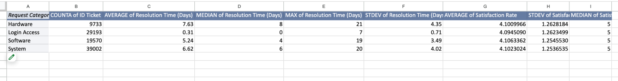

**Observation:**

* **Ticket volumes: System (39,002) > Login Access (29,193) > Software (19,570) > Hardware (9,733).**

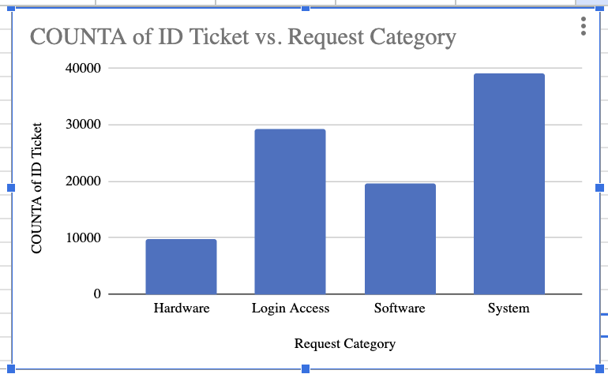

* **Historical category-wise data shows clear differences:**
  + **Hardware tickets take the longest to resolve (avg ~7.6 days, SD ~4.3) and show high variability, with max cases reaching 21 days. Although, the no. of tickets of this category are the least.**

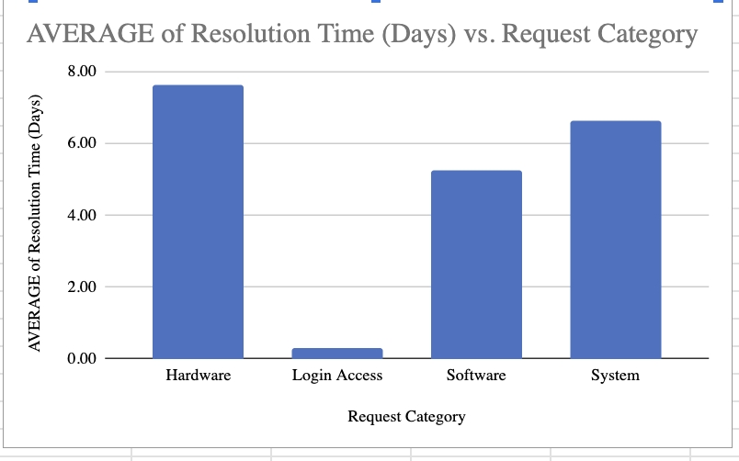

* + **System tickets has the highest ticket volume and higher resolution time(i.e. they are also slow ~6.6 days avg), with long tails up to 20 days.**
  + **Software tickets are somewhat faster (~5.2 days avg), though still not short.**
  + **Login Access requests are resolved extremely quickly (~0.3 days avg) with very low variability, reflecting standardized/automated processes.**

* **Satisfaction rates, however, are clustered tightly around 4.09–4.11, with medians at 5 for all categories and similar variability (SD ~1.25). This means satisfaction does not vary strongly by request category, even when resolution times differ.**
* **For understanding, let’s consider a simple “workload days” proxy = count × avg time :**
* **System ≈ 39,002 × 6.62 -> ~258k days (largest share)**
* **Software ≈ 19,570 × 5.24 -> ~103k days**
* **Hardware ≈ 9,733 × 7.63 -> ~74k days**
* **Login Access ≈ 29,193 × 0.31 -> ~9k days**
* **The biggest bottlenecks by impact are where high volume and long time intersect—System first, then Software, then Hardware.**

**Insights:**

* **System, Software categories have high tickets volumes suggesting higher number of issues.**
* **Historical data clearly identifies Hardware and System requests as the slowest and least predictable. These categories represent bottlenecks that delay service.**
* **But, if we look at “workload days” proxy, it tells us that System and Software categories to be most stressed.**
* **Login Access demonstrates what is possible when automation and streamlined tools are applied: near-instant and consistent resolutions.**
* **Since satisfaction scores are already clustered high across categories, tech investment may not spike the average satisfaction number— but they will likely reduce variability, agent stress, and negative outliers, which in turn stabilizes customer experience.**
* **Therefore, investment in technology for Hardware, System, and Software categories is most likely to reduce resolution times and inconsistency, indirectly supporting higher satisfaction and employee efficiency.**

**Recommendation:**

* **Investment in tech, specially in System and Software will lead to less ticket volumes in these categories and reduce the Avg resolution time as well.**
* **Target System, Software and Hardware in tech upgrades (in that order)**
* **Replicate the automation success of Login Access in other categories.**
* **Post-investment, track not only average satisfaction and avg resolution time, but also variance and outliers (e.g., % of tickets taking >10 days, % of satisfaction scores <3) to capture true impact.**

**7. What are the key performance metrics for IT agents, and how can they be improved, do we need to fire any agents?**

**Observation:**

* **Key performance metrics considered:**
  + **Average Resolution Time**
  + **Average Satisfaction Rate (service quality)**
  + **Tickets per Agent (workload contribution)**
* **Agents were classified as *High/Normal/Low* in each metric using percentile benchmarks (25th/75th).**

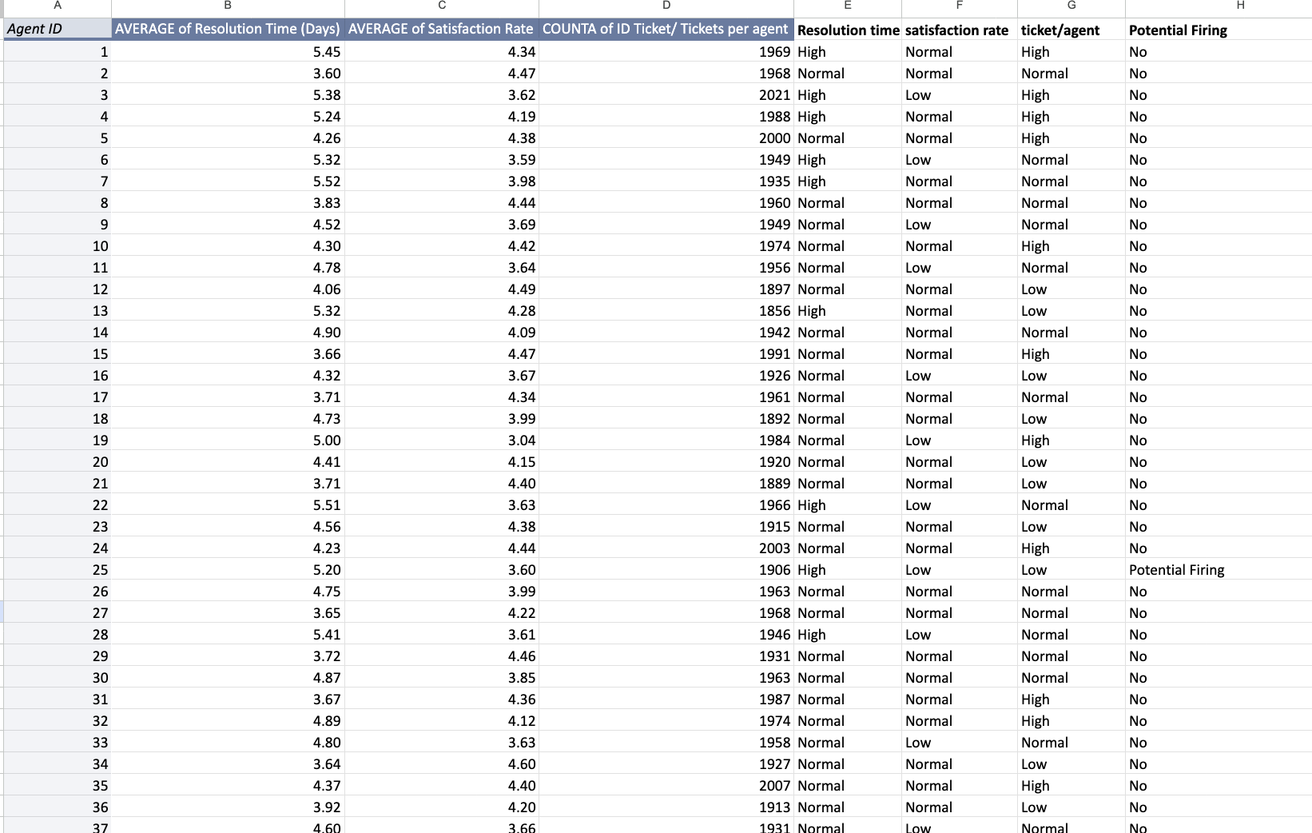

* **A decision rule was applied: an agent was marked as Potential Firing only if all three conditions were met simultaneously:**
  + **Resolution Time = High**
  + **Satisfaction Rate = Low**
  + **Tickets per Agent = Low**
* **Using this rule on overall data, only Agent 25 was flagged as Potential Firing.**
* **However, overall averages can be misleading, so year-wise checks were also done using slicers, to check which Agents are performing bad consistently:**

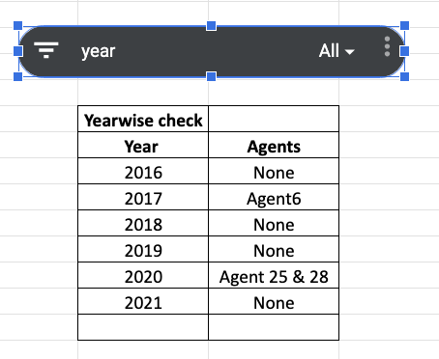

* **This shows some agents underperform occasionally (e.g., Agent 6 in 2017), but not consistently.**
* **Since Only Agent 25 appeared as “Potential Firing” in overall and recent years (2020), therefore lets focus on Agent 25**

**Detailed Comparison:**

* **A pivot was created for Agent 25 only, and another for all other agents, with Year–Quarter as rows.**
* **Based on this pivot, tables were created for all 3 metrics. Idea is to further scrutinize this Agent’s performance compared to others.**

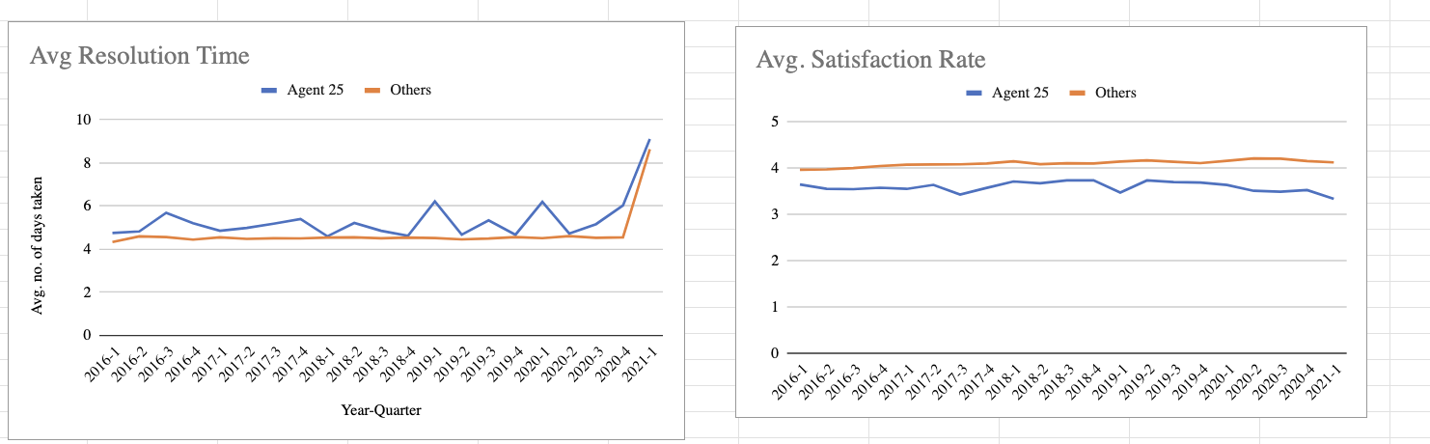

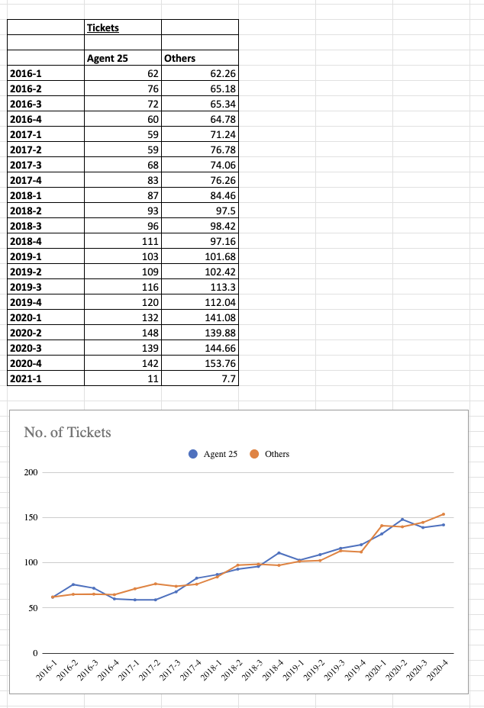

* **On comparison (Tables + Charts):**
  + **Agent 25 consistently shows higher average resolution time than peers.**
  + **Agent 25 consistently shows lower satisfaction scores than peers.**
  + **Ticket volume for Agent 25 is also not significantly higher to justify weaker performance.**
* **The time-series charts clearly show Agent 25 underperforming quarter after quarter, unlike one-off cases of others.**

**Insight:**

* **Agent 25’s underperformance is not a one-time anomaly; it is a consistent pattern visible both in aggregate and over time.**
* **Other agents flagged in single years (e.g., Agent 6 in 2017, Agent 28 in 2020) show this only as temporary dips, hence firing is not justified for them.**
* **Therefore, the only serious concern is Agent 25, who lags in both efficiency (resolution time) and quality (satisfaction rate).**

**Recommendation:**

* **Primary KPIs for agents should be tracked regularly: Resolution Time, Satisfaction Rate, and Tickets per Agent.**
* **Introduce a three-tier classification for corrective action on underperforming agents:**
  + **Training Needed (if failing in 1–2 metrics)**
  + **Under Observation (temporary underperformance)**
  + **Potential Firing (failing in all 3 metrics, consistently across multiple periods)**
* **For Agent 25:**
  + **Immediate corrective action plan (training, performance review, mentoring).**
  + **If no improvement over the next review cycle, termination should be considered.**
* **For other agents:**
  + **Provide targeted training where needed (e.g., soft skills for satisfaction, process optimization for resolution time).**
  + **Maintain fairness by not penalizing one-off dips.**

**8. How do employee demographics (e.g., department, seniority) impact satisfaction and ticket outcomes?**

**Observation:**

* **The dataset does not provide demographic information of Employees, such as department or seniority.**
* **So we used the data of the Agents provided to us.**
* **To approximate seniority, we used the agents’ Date of Birth and calculated their ages (as of 31 Jan 2021).**

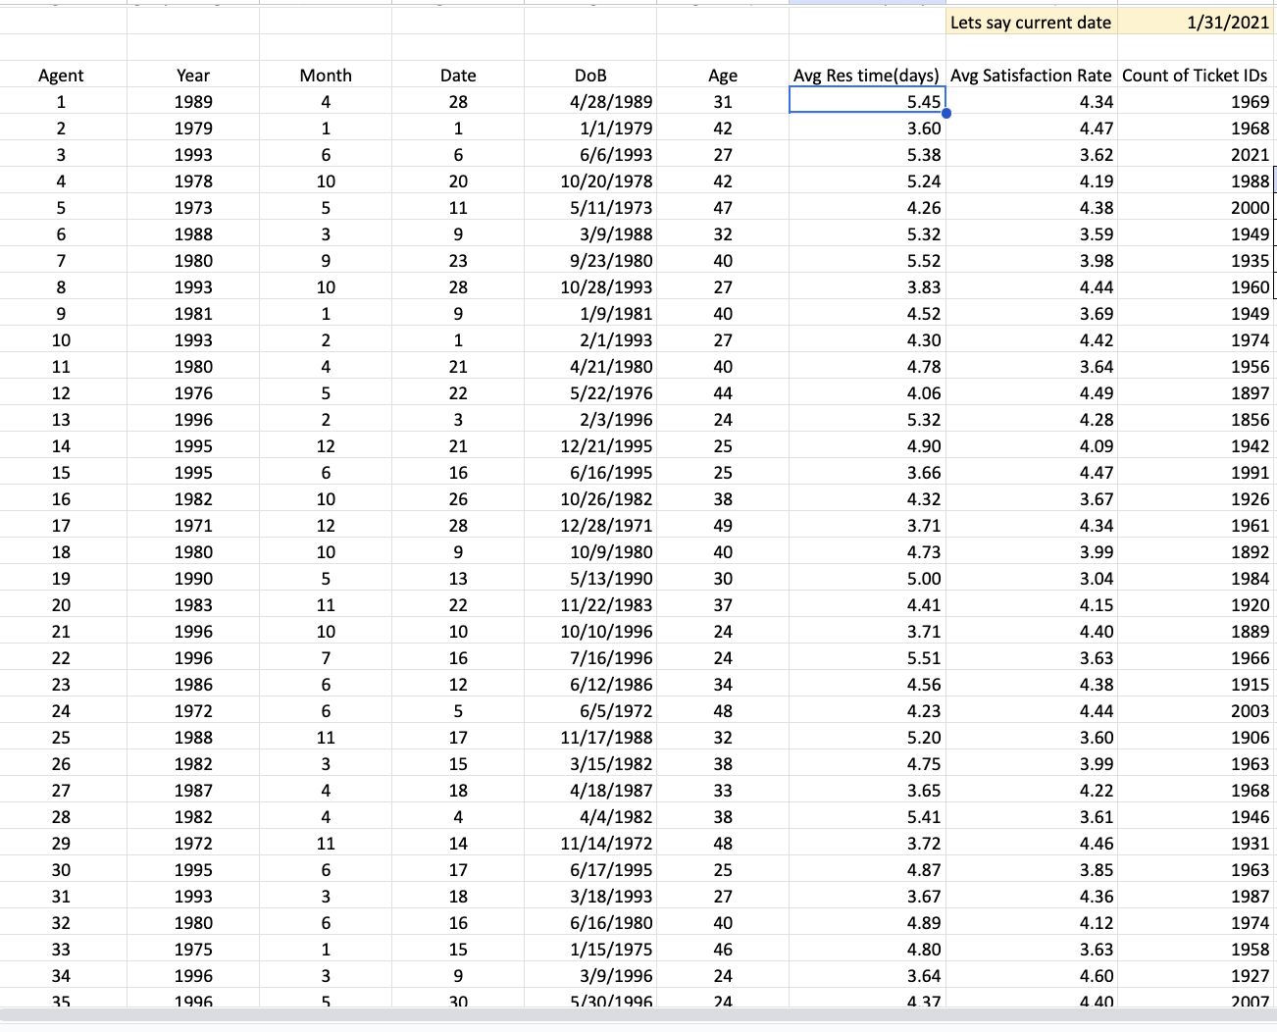

* **Agents were then grouped into three age bands:**
  + **Group A (20–29 years) – 14 agents**
  + **Group B (30–39 years) – 18 agents**
  + **Group C (40–50 years) – 18 agents**

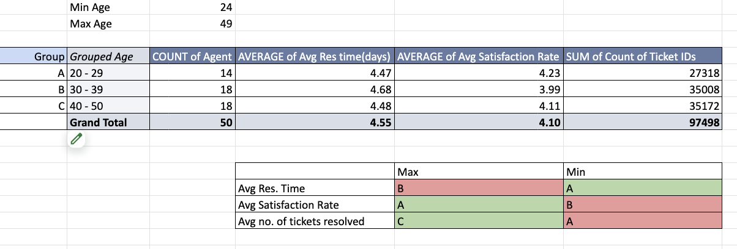

* **For each group, we compared Average Resolution Time, Average Satisfaction Rate, and Total Tickets Resolved (see pivot).**

**Key Findings:**

1. **Resolution Time:**
   * **Longest in Group B (30–39 years) with an average of 4.68 days, compared to Group A (4.47 days) and Group C (4.48 days).**
   * **Indicates mid-career agents may be slower in handling tickets relative to peers.**
2. **Satisfaction Rate:**
   * **Lowest in Group B (3.99) vs Group A (4.23) and Group C (4.11).**
   * **Suggests Group B struggles not only with speed but also with service quality.**
3. **Tickets Resolved (Workload):**
   * **Group C handled the most tickets (35,172 total) → senior agents are taking the heaviest workload.**
   * **Group B handled nearly the same volume (35,008 tickets) but with poorer resolution time and satisfaction, suggesting inefficiency.**
   * **Group A handled the fewest tickets (27,318 total), which is expected as younger agents may be allocated fewer or less complex cases.**

**Insight:**

* **Group A (20–29 years): Fastest resolution, highest satisfaction, but lowest ticket volume -> younger agents are efficient but may not yet handle full workloads.**
* **Group B (30–39 years): Clearly underperforming across all metrics -> highest resolution time, lowest satisfaction, and despite handling large volumes, the outcomes are weaker. This could indicate issues like process bottlenecks, burnout, or lack of adaptability.**
* **Group C (40–50 years): Carry the heaviest workload while maintaining steady resolution time and acceptable satisfaction. They balance volume with quality better than Group B.**

**Recommendation:**

* **Focus improvement efforts on Group B (30–39 years):**
  + **Provide targeted training to improve both technical efficiency and customer interaction.**
  + **Review workload distribution — they handle high ticket volumes but inefficiently, which hurts both resolution and satisfaction.**
* **Group A (20–29 years): Gradually increase workload while monitoring quality, as they show strong early performance.**
* **Group C (40–50 years): Continue assigning higher volumes, but support them with automation/tools to prevent fatigue and ensure long-term sustainability.**
* **If demographic details like department/tenure become available, repeat this analysis with more precise grouping for deeper insights.**

**9. Identify the trends for IT support operations based on ticket volumes and satisfaction, and mention the peak and stable times?**

**Observation:**

* **Ticket volumes were analyzed quarter-wise across 2016–2020 using pivot tables.**

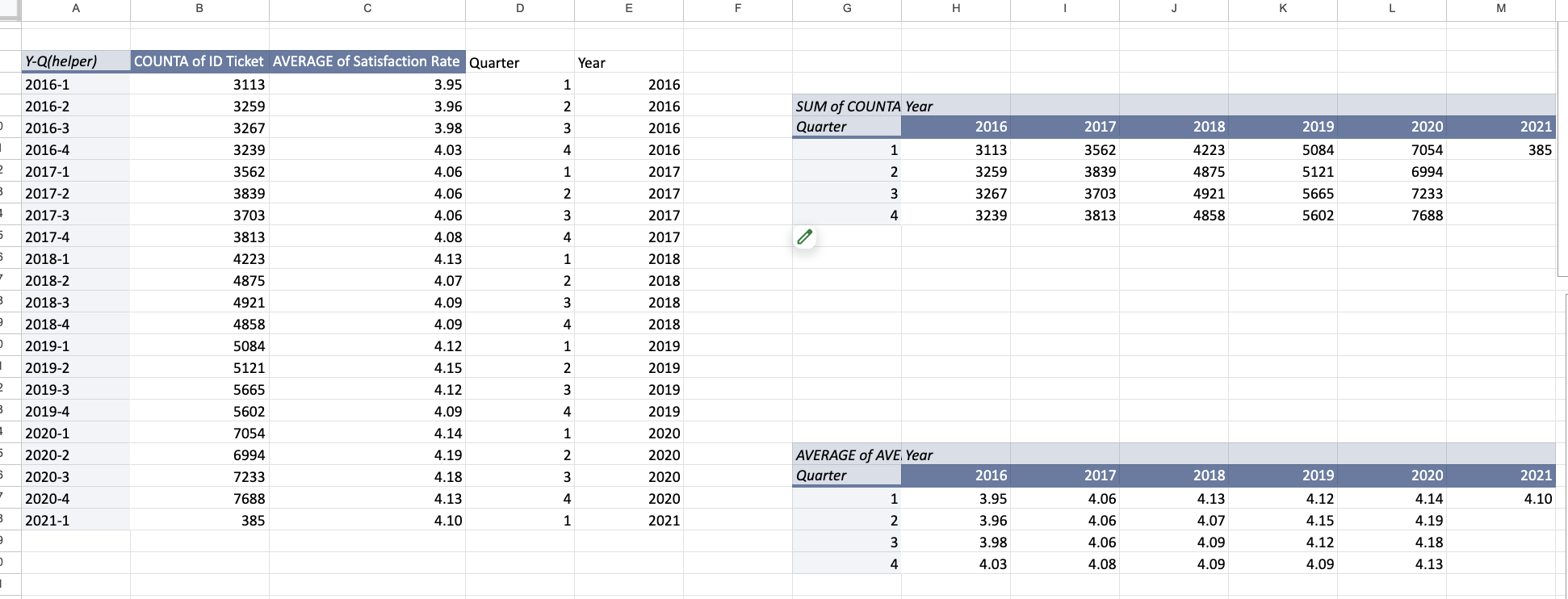

* **The data shows a clear upward trend in ticket volumes:**
  + **2016–2017: steady volumes around 3,000–3,800 tickets/quarter.**
  + **2018: moderate growth, crossing 4,800–5,000 tickets/quarter.**
  + **2019: further increase, reaching 5,000–5,600 tickets/quarter.**
  + **2020: peak levels, consistently 7,000+ tickets/quarter, with Q4 2020 highest at 7,688 tickets.**

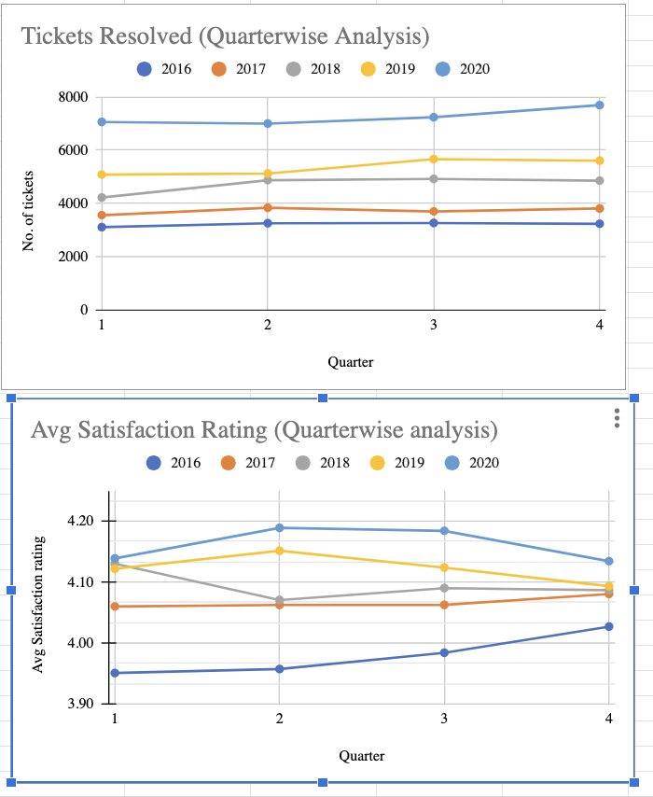

* **Average Satisfaction Ratings remained remarkably stable across the same period:**
  + **Early years (2016–2017): around 3.95–4.08.**
  + **Later years (2018–2020): slightly higher and steady, in the 4.09–4.19 range.**
  + **Quarter-wise variation within each year was minimal (<0.2 points).**

**Insight:**

* **Ticket volumes show a strong growth trajectory, with clear peak activity in 2019–2020.**
* **There’s no off-peak period trend as such, when we look at the quarterwise metrics over the years.**
* **The period 2016–2017 can be considered the stable baseline, with low and consistent volumes.**
* **Despite rising workloads, satisfaction did not deteriorate — instead, it held stable and even improved marginally, suggesting that IT support capacity scaled effectively with demand.**
* **No specific quarter shows a dramatic drop in satisfaction, indicating service resilience during peak loads.**

**Recommendation**

**Since satisfaction has been stable even in peak times, maintain focus on scalability and consistency, ensuring support processes can handle further volume increases without quality loss.**

**Conclusion:**

* **Ticket volumes in IT support operations have steadily grown, peaking in 2019–2020 with Q4 2020 as the busiest period. 2016–2017 represent stable, low-volume years. Average satisfaction remained stable and resilient (~4.0–4.2) throughout, even during peaks, indicating strong operational capacity**

**.**

**10. What metrics should be included in the final dashboard to provide a comprehensive view of call center performance and guide investment decisions?**

* **The dashboard provides a comprehensive view of call center performance by tracking key metrics such as total tickets handled, average resolution time, average satisfaction rating, and average tickets per agent.**
* **Trend charts for satisfaction rate, resolution time, agent efficiency scores, and ticket volumes highlight performance over time**
* **Interactive filters for year, quarter, age group, issue type, priority, severity, and request category allow deeper analysis of specific segments.**

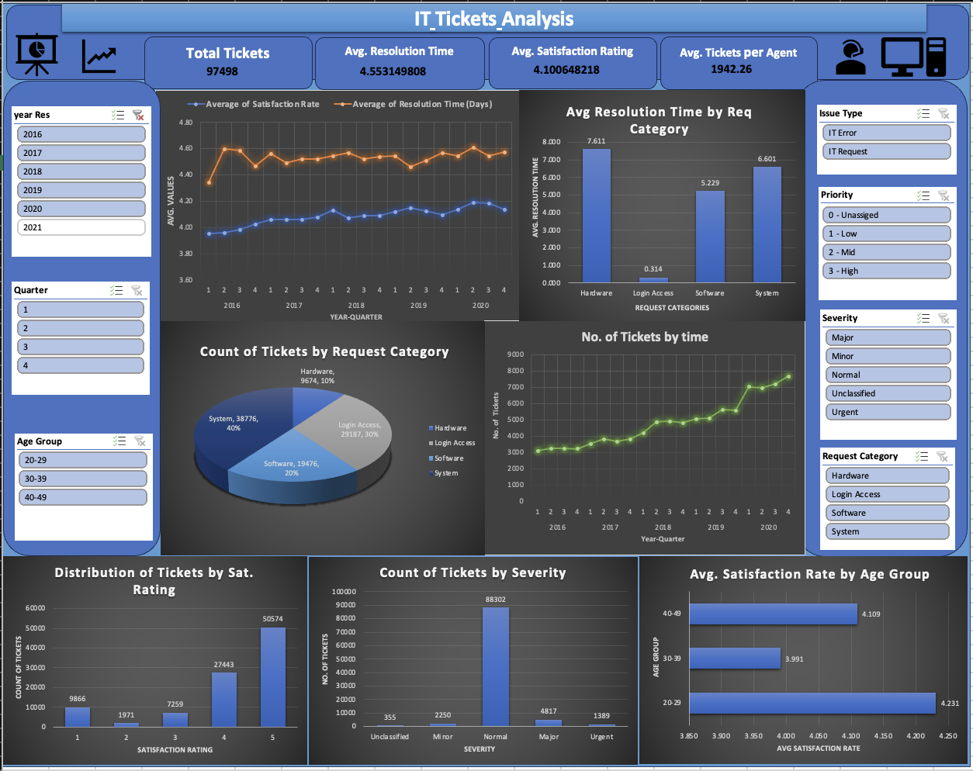

* **Together, these metrics give a balanced picture of service quality, efficiency, and workload, enabling management to identify gaps and make informed investment decisions in staffing, training, or technology.**